Rothienorman School Parent Partnership Group (PPG) Chairperson’s Report 2015-2016
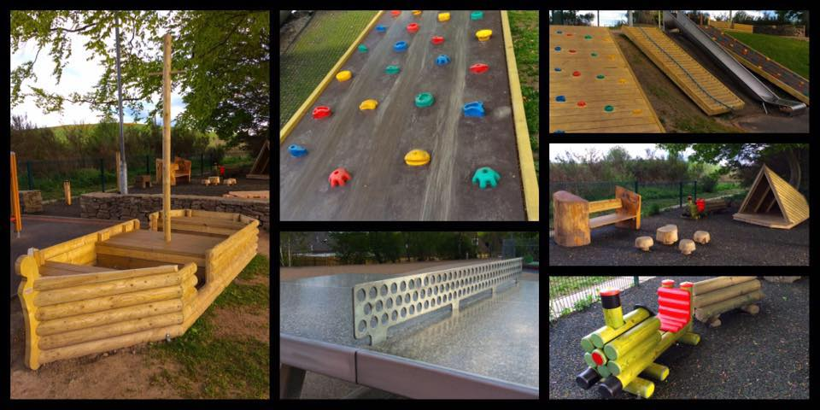
What we have done for our children’s school and nursery over the past year

Our Input into School Our Fundraising Activities
School Development plan Football Fun Day
Child safety Intoxicating Tea Party
Pupil reports/learning logs Halloween and Valentines Discos
Positive Relationships policy Christmas Cards
Traffic and road safety issues Christmas Shopping Event
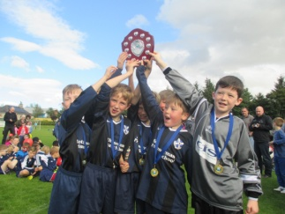
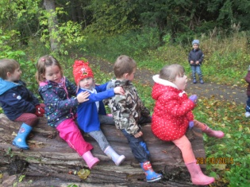
School uniform suppliers Christmas Show Raffle
Primary 1 induction Tea towels
School activities and trips Spring Fair
School photographers Easter Egg Hunt
Open afternoon Chocoholics Sales
Communication with parents Easy Fundraising online
Parent Coffee mornings Asda Green tokens

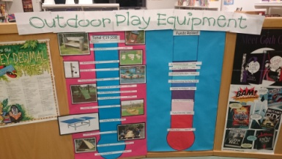
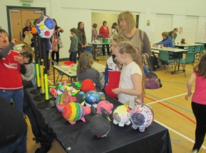
Our Funds Summary 2015/2016
Income: £8543.63
Expenses for fundraising: £2821.87
Net income: £5721.76
FUNDS SPENT ON PUPIL ACTIVITIES AND EQUIPMENT: £4886.88

A massive thank you to the PPG Committee members, parents and businesses for helping us to raise these funds over the past year. With all your help, time and input we have been able to provide better experiences for our children at Rothienorman School and nursery.

Funds raised this year spent on:
Outdoor Play Equipment £4000
Sports Day ice cream and water for all school and nursery children School trips
Buses for Primary 4 for swimming lessons Crackers for Christmas lunches
Bus for outdoor learning to Fyvie for nursery children

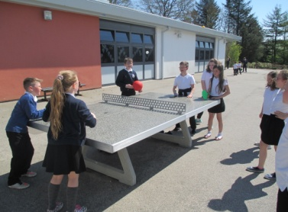
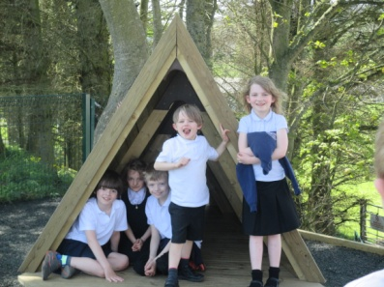
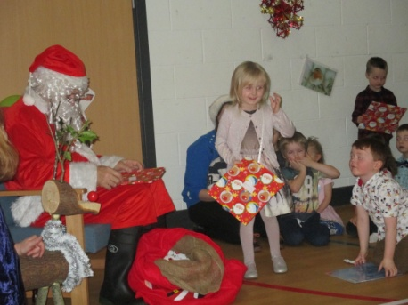
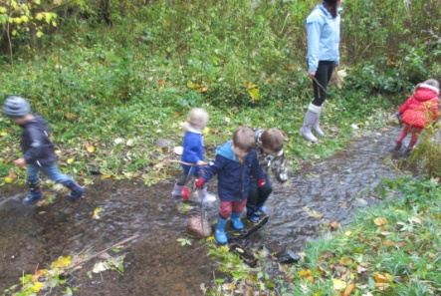

What can WE do next year?
What can YOU do for your child’s school and nursery?

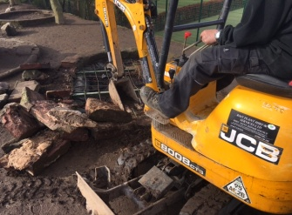
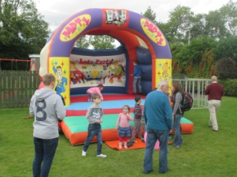
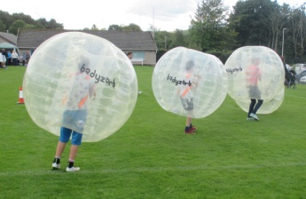
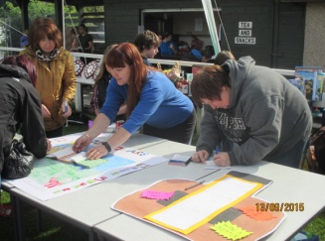
Come along to our Annual General Meeting (AGM) on Monday 5th September 7pm School Hall

