Rothienorman Primary School
Promoting Positive Relationships Policy
(including Anti-Bullying)

Contents

Part 1: Background and Context
- What is behaviour?
- Aims
- Rights
- Responsibilities

Part 2: Encouraging Better Relationships, Better Learning, Better Behaviour
- Golden Rules
- Encouraging positive behaviour
- Rewarding positive behaviour
- Restorative and Solution Orientated Practices
- Being Cool in School

Part 3: Inappropriate behaviour
- Consequences
- Bullying
- Challenging and/or violent behaviour
- Recording and Monitoring

Part 4: Staged Intervention
- Partnership Working
- Multi Agency Action Plan (MAAP)
- Aberdeenshire Staged Intervention Supporting Teaching (ASSIST)

Appendices
- Appendix 1 – Rothienorman Vision, Values and Aims
- Appendix 2 – Wellbeing (GIRFEC and the Health and Wellbeing Indicators:
SHANNARI)

References and Other Reading
Part 1: Background and Context

‘Developing good relationships and positive behaviour in the classroom, playground and wider community is essential for creating the right environment for effective learning and teaching. Where children and young people feel included, respected, safe and secure and when their achievements and contributions are valued and celebrated, they are more likely to develop self-confidence, resilience and positive views about themselves. This applies equally to all staff in the learning community. ‘
Better Relationships, Better Learning, Better Behaviour 2013

Within Curriculum for Excellence (CfE) all staff are expected to be proactive in promoting positive relationships and behaviour in the classroom, playground and the wider school community. There are specific experiences and outcomes in Health and Wellbeing which are the responsibility of all practitioners, who have a role in:
- establishing open, positive, supporting relationships across the community, where children and young people will feel that they’re listened to, and where they feel secure in their ability to discuss sensitive aspects of their lives;
- promoting a climate in which children and young people feel safe and secure;
- modelling behaviour which promotes health and wellbeing and encouraging it in others;
- using learning and teaching methodologies which promote effective learning;
- being sensitive and responsive to the wellbeing of each child and young person.

What is behaviour?
Behaviour is a response of an individual or group to an action, environment, person or stimulus. At Rothienorman we recognise that CfE cannot be delivered without good relationships and positive behaviour.

“The starting point for learning is a positive ethos and climate of mutual respect and trust based upon shared values across whole school communities where everyone can learn and work in a safe and peaceful environment.”
Building the curriculum for excellence through positive relationships and behaviour, 2009.

Aims
- To create a positive, caring, calm and purposeful atmosphere where all pupils will learn, are motivated and challenged.
- To work in partnership with parents, pupils and other agencies to maintain and build good relationships, prevent bullying and promote the well-being of all children.
- To be consistent and fair in our approach to managing behaviour.
- To encourage pupils to recognise that they have the responsibility to make a choice in their behaviour within the established rules, rewards and consequences.
Context of Policy
This policy has considered the Aberdeenshire policies and guidelines as well as the document ‘Better Relationships, Better Learning, Better Behaviour’ document on promoting positive relationships.

At Rothienorman we acknowledge that a nurturing ethos, and positive behaviour management, are key to providing an effective learning and teaching environment. Our policy has been founded within the aims and principles of ‘A Curriculum for Excellence’ and ‘Getting it Right for Every Child’ (GIRFEC). It will help us to deliver our school Vision, Values and Aims (see Appendix 1).

Rights
“Children have the right to a good quality education. This education should help them use and develop their talents and abilities. It should also help them to live peacefully, protect the environment and respect other people.”
UN Convention on the Rights of the Child.
Pupils
- To be able to enjoy their learning.
- To be treated with respect.
- To be listened to.
- To feel safe.

Staff
- To enjoy the teaching and learning environment in which they work.
- To be treated with respect.
- To be listened to.
- To feel safe.

Parents/Carers
- To know that their children are safe and happy.
- To participate in positive communication with the school.
- To be treated with respect.
- To be listened to.

Part 2: Encouraging Positive Behaviour and Achievement
“Developing good relationships and positive behaviour in the classroom, playground and wider community is essential for creating the right environment for effective learning and teaching. Where children and young people feel included, respected, safe and secure and when their achievements are valued and celebrated, they are more likely to develop self-confidence, resilience and positive views about themselves. This applies equally to all staff in the learning community.”
Better Relationships, Better Learning, Better Behaviour 2013
The ethos and culture of Rothienorman is the foundation in which we build a supportive, inclusive and peaceful learning environment. This positive ethos can be further developed through our whole school behaviour approach.

Golden Rules
The Golden Rules set out our expectations in terms of behaviour. These rules were drawn up in consultation with staff, parents and pupils and are reviewed annually.

- Do your best.
- Look after things.
- Be kind and thoughtful.
- Keep yourself and others safe.

These rules allow the creation of a positive ethos, peaceful learning environments, improved relationships and positive behaviour at Rothienorman School. This ensures that our pupils are included, engaged and involved throughout their school careers. They are kept very simple intentionally so that they are easy to understand, remember and refer to.

Responsibilities
It should be recognised that all parties have responsibilities for a child’s education to ensure all of their needs are being met.

Pupils
- to behave in a manner which allows others to reach their full potential.
- to treat others with respect .
- to listen to others .
- to allow others to feel safe.
- to follow our School Rules, and any individualised behaviour programme.

Staff
- to be aware of current and relevant documentation, including policies, and the range of strategies, and sources of advice, but also of the many factors which influence behaviour and are out with our control.
- to treat pupils fairly and with respect and pay regard to confidentiality.
- to establish open, positive, supporting relationships across the community, where pupils will feel that they are listened to, and where they feel secure in their ability to discuss sensitive aspects of their lives.
- to promote a climate in which pupils feel safe, secure and stimulated.
- to model behaviour which promotes health and wellbeing and encourages it in others.
- to use learning and teaching methodologies which ensure that all children’s needs are being met.
- to be sensitive and responsive to the wellbeing of each child and young person and to be realistic with regard to the rate of change in pupils behaviour.
- to have high expectations for children’s learning and achievement.
- to work collaboratively with colleagues and to share ideas and seek support and advice.
- to keep parents/carers informed of their child’s educational, personal and social development, including issues relating to behaviour. This includes at interagency meetings, annual parents meetings and reports but there may be occasions when the class teacher or head teacher has a concern and so contact will be made with parent/carers.
- to apply this policy fairly and consistently .

Parents/Carers
- to take an active role in their children’s education.
- to support the school in encouraging positive behaviour.
- to treat all staff and pupils in the school with respect and pay regard to confidentiality.
- to inform the school if they have any concerns relating to behaviour in the school; contact will be made in either writing (via homework diary, letter or email), telephone or at an organised meeting.

Encouraging Good Relationships and Positive Behaviour
At Rothienorman we use a variety of ways to promote and reward positive behaviour and achievement. This is not an exhaustive list but in order to encourage positive behaviour we may use some of the following or indeed other strategies too:

- An inclusive ethos, encouraging everyone to feel part of and proud of our school.
- Buddies – Buddies are older pupils who help the Primary 1s at the start of the year and mentor/support new pupils to the school.
- Class seating plan – Teachers may have seating arrangements in the classroom to support individual’s behaviours and relationships.
- Clear structures and expectations for all
- Dialogue which builds relationships and encourages respect between all, for example everyone learns British Sign Language (BSL) in order to communicate with all members of the school community.
- Encouraging Responsibility – Citizenship Groups are used to encourage children to take on more responsibility in the life and works of the school and its community.
- Health and Wellbeing Curriculum – This may include the use of Cool in School, Living and Growing and Stonewall resources, inputs from other professionals i.e. RSPCA officer and citizenship groups.
- Individual Educational Plan – These are used to focus on targets, for a particular pupil, and how these can be achieved.
- Intervention and Prevention – A small amount of children may receive 1:1 or small group targeted support to help them improve their behaviour.
- Motivating and challenging activities to keep children focused.
- Social Stories –These are stories which are used to model a specific behaviour, often for an individual child.
- Stories, drama and role-play – These are used to provide a scenario to open up discussion on a behaviour or topic.
- Use of Restorative Approaches (detailed later in this policy).
- Visual Timetables/targets – Visual timetables/targets are used for whole class or specific individuals; these are updated weekly/daily and reflected on by both pupil and teacher.

Rewarding Positive Behaviour
- Positive Praise – Praise is used as positive reinforcement for specific behaviours. All staff ‘catch’ the children showing positive behaviour, praise them and discuss the positive impact this has on them and their learning.
- Stickers and Praise Stars – may be used for specific behaviours of individual children to identify and celebrate achievements.
- Table Points – may be used to reward a whole table for showing positive behaviour or a good work ethic.
- Golden Time – pupils can earn a planned activity at the end of the week. Time may be deducted if pupils have behaved inappropriately.
- Recognition of Achievement at Assemblies and in school newsletters– e.g. showing of work, demonstration of skills, presentation of certificates etc.
- Displays of work/achievements on notice boards – as part of wall displays in either their classroom or another area of the school.
- School Newsletters – These are used to recognise and highlight achievements.
- House Point System – There are 4 houses at Rothienorman named after local areas; Bennachie, Blackford, Cranna and Fraser. Children are allocated a house when they join the school. All members of staff can award house points (in the form of raffle tickets) for excellent work, positive behaviour or extra-curricular achievements. These points are totalled up weekly and shared at assembly. The house with the highest amount of points at the end of the session win the house trophy and a special treat.
- Raffle Tickets – The children’s individual house points are totalled up weekly and the children receive a certificate once they have reached a certain amount;
- Bronze certificate (25 house points)
- Silver certificate (50 house points)
- Gold certificate (75 house points)
- Platinum certificate (100 house points)
- At the end of the Christmas and summer terms there is a draw of raffle tickets where pupils have an increased chance of winning a prize, the more raffle tickets they have earned.
- Primary 7 trophies – At the end of the year trophies are awarded to outstanding Primary 7 pupils who have made particular contributions in the following areas and are thought of as a; Sports Personality, Successful Learner, Effective Contributor, Responsible Citizen or Confident Individual. Recipients of these awards are voted for by staff and classmates.

Restorative and Solution Orientated Practices
“Research has found that restorative practices can offer a powerful and effective approach to promoting harmonious relationships in schools and to the successful resolution of conflict and harm.”
Improving relationships and positive behaviour in Scotland's schools, 2008.

Pupils and staff work together to achieve a common knowledge and understanding of emotions and feelings in order to have the emotional literacy necessary for restorative conversations where situations are resolved and solutions agreed upon.

Restorative practices cover a range of strategies including:
- developing a restorative climate in school with activities such as peer support and circle time.
- developing restorative conversations when staff and/or peer mediators intervene in a situation.

Restorative practices:
- Build and repair relationships.
- Develop and maintain mutual respect.
- Preserve a sense of belonging and strengthen community ties.
- Ensure everyone is given a voice and feels heard.
- Empower those with conflict to resolve it for themselves.
- Ensure accountability.
- Develop empathy and conscience.

These restorative practices ensure that children feel safe, they belong, are respected and have valuable positive relationships with others.

Restorative approaches ensure that the person who is showing undesirable behaviour acknowledges responsibility for this and takes steps to repair harm. Through using restorative language this then allows the child to understand, manage and reflect on their own behaviour. Further information on Restorative approaches can be found in the Rothienorman School Restorative Approaches information leaflet.

Being Cool in School
‘Being Cool in School’ is a personal and social development programme which is often used by classes or groups in Rothienorman. It helps children to learn the skills of getting on with others, coping positively with everyday situations, and showing sensitivity and respect while holding true to who they are. This programme encourages staff, parents and pupils to work together to help children learn respect for themselves and others.

Part 3: Inappropriate Behaviour
Despite the best efforts of all, incidents of unacceptable behaviour or bullying are still likely to occur. These behaviours may vary from consistent low level disruption to actions which may merit exclusion from school. Pupils or parents/carers should report incidences which they feel staff should be aware of, to a member of staff, as soon as possible to ensure it is dealt with efficiently and appropriately.

“There is a wide range of factors which affect a young person’s behaviour, and there is no one way of dealing with the complex problems which can be faced by children, young people and their families. Children’s experiences and behaviour in school cannot be disassociated from all other aspects of their lives, including within their families and communities.”
Better Behaviour, Better Learning, the Discipline Task Group, 2001.

Inappropriate behaviour can be challenging for staff, parents and pupils. At Rothienorman we understand that challenging behaviour is much less common where staff and learners enjoy positive relationships based on mutual respect and consideration. These strengths are supported and reinforced by a shared understanding and acceptance of the school’s vision, values and aims (see Appendix 1). Staff know learners as individuals and respond to their differing personalities, circumstances and learning needs. This leads to a positive learning climate in individual classrooms and in the school in general.
Whilst our overall approach to managing behaviour is restorative, a variety of strategies are used to encourage children to reflect upon the consequences of their actions and think how they may behave differently if faced with similar circumstances in the future.

Strategies may include:
- restorative discussion with a member of staff.
- disappointed or disapproving look.
- ignoring the challenging behaviour and praising the positive behaviour of others.
- separation from a group.
- change of seating arrangements in the classroom.
- separation from other pupils at break or lunchtime to encourage time for reflection.
- letter of apology or drawing (for younger children).
- home/school behaviour chart or weekly updates.
- withdrawal of privileges i.e. golden times, some of their break or involvement in extra-curricular activities in order to repair relationships/damage or give time for reflection.
- discussion with Head Teacher or other relevant adult.
- agreement and implementation of an Individualised Education Plan.
- phone call home to parents or meeting to discuss inappropriate behaviour and how we are going to move forward.
- courting exclusion (warning of exclusion).
- exclusion procedures of varying lengths (see Aberdeenshire Education, Learning & Leisure Service Guidelines for Parents, Guardians, Carers on Exclusion of Pupils from School).
- removal from the register.

The action taken will depend on the nature and context of the behaviour, including the intent. It is also important to consider the individual involved and what is likely to be effective. At Rothienorman we try to ensure that any consequences in response to unacceptable behaviour should not undermine the child’s self-esteem. Parental involvement can be considered at any stage based on professional judgement and awareness of previous discussions with parents.

Bullying
This policy has considered the Aberdeenshire ‘Anti-Bullying Policy for Learning Establishments, 2015’ and the ‘Anti-Bullying Guidance for Learning Establishments, 2015’. These documents provide additional support and information for staff on this area.

Bullying takes place when the actions of an individual or group of people cause harm to someone by taking advantage of an imbalance of power within a relationship (whether perceived or real). Bullying behaviour is abusive.
Bullying behaviour is often displayed as a result of past experiences which affect and impact on current actions.
Bullying can be verbal, physical, emotional, sexual or cyber. People who experience bullying behaviour feel vulnerable and/or socially isolated.

Our stance is that bullying in any form is intolerable and unacceptable. Parents/carers, pupils and teachers have a responsibility to work in partnership to maintain a high standard of behaviour and an environment free from bullying behaviour. Rothienorman School believes that everyone should be treated equally and with respect.

As with all aspects of behaviour, Rothienorman School works to raise awareness, to educate and support pupils, staff and parents/carers. We aim primarily to prevent bullying behaviour. Most incidents of inappropriate behaviour in schools are remedied through behaviour management strategies before they evolve into bullying. Everyone is however aware of what to do when bullying behaviour is displayed, and how to support those involved. Information is also available for pupils, parents/carers and teachers about support available beyond school (e.g. Childline, Samaritans, Police Scotland, Parentline). Training and key information is provided to staff on bullying and all aspects of behaviour management. Communication with all parties involved, including parents/carers, is at the heart of prevention strategies and in how we respond to incidents of bullying behaviour. We use restorative approaches, (detailed previously), to build or repair relationships. The language ‘victim’ and ‘bully’ should be avoided as this labels those involved in bullying incidents and this can be unhelpful. Taking action to resolve a bullying situation must be given high priority.
All incidents of suspected bullying will be reported to the Head Teacher to be dealt with appropriately and recorded and monitored.

Challenging and/or Violent Behaviour
In a minority of cases, staff may have to deal with extremely challenging behaviour. Advice and training is given to all staff on how to deal with any child displaying very challenging behaviour. At Rothienorman we have a folder containing advice on how to deal with individual children’s challenging behaviours available for all new and visiting staff. There is also an ‘immediate assistance needed’ card in every room in the school. All abusive and violent behaviour is recorded and reported following Aberdeenshire Guidelines.

Risk Assessment
Risk Assessments are carried out if a pupil is believed to be a potential risk to themselves and, or others. Strategies and procedures are then implemented to ensure that potential risks are at an acceptable level and that pupils are able to learn and play in a positive environment. The safety of all pupils and staff is of paramount importance. A code word or ‘immediate assistance needed’ card can be used so that another pupil can be sent with a message to another adult (while a member of staff remains with the other pupils) who will then understand the urgency of the situation.

Room 7
We have a small space, Room 7, set up as an area where certain children can go to, by agreement, if they are feeling unsettled or emotional and need some time to themselves or to calm down. This functions well, enabling the class to continue with their work as normal while the child who is finding it difficult to deal with their emotions, has a space to go to where they can calm down without risk to others or themselves. A member of staff who is not currently teaching would be made aware of a child who is using Room 7 and would assess the best course of action in the circumstances.

C.A.L.M. (Crisis, Aggression, Limitation and Management) techniques
If a person is in danger, physical intervention may be necessary to prevent injury. This is the only circumstance in which physical intervention should take place. In an extreme situation where a person or persons are at risk, minimal physical force should be used to ensure safety. Two members of staff should be present (where possible) and ‘CALM or Small Holds’ trained where possible. (For more information see the Aberdeenshire Council Policy: The Use of Physical Intervention in Educational Establishments.)

Recording and Monitoring
Recording and monitoring of any significant behaviour (including bullying) will be recorded in either (or both) a pupil’s file / chronology or in a file marked ‘Incidents of Inappropriate Behaviour and/or bullying which will be stored in the head teacher’s office. Incidents which will be documented will include ones of a serious or ongoing nature, as well as incidents where a member of staff, pupil or parent/carer feels that they would like it documented.
By recording such incidences we will be able to:
- ensure that there has been an appropriate and effective response.
- identify recurring patterns including; involvement of particular children, staff or other adults, where and when bullying takes place, aspects of prejudice or discrimination underlying bullying, consideration of personal or additional support needs.
- identify if a particular problem is ongoing and whether further professional development may be beneficial to staff.

Aggressive or violent behaviour, by pupil or adult, will be reported on the Aberdeenshire Violent Incident Report Form. Racially based incidents will be recorded on Aberdeenshire Council’s Racial Incident Monitoring Form.

Part 4: Staged Intervention

Partnership Working
“Genuine partnership between pupils, staff, parents and carers, the wider community and other agencies in the public and voluntary sectors is essential to encourage, support and develop initiatives that promote health and wellbeing, GIRFEC values and principles underpin work not just in education but in those other agencies as well, providing a common approach and language which helps develop effective partnership working. “
Better Relationships, Better Learning, Better Behaviour 2013.

Staff consult with, and are supported by Educational Psychologists, Pupil Support Workers, Family Support Workers, Intervention and Prevention Teachers, Meldrum Additional Support for Learning Teachers, School Nurse, Quality Improvement Officer, Child and Family Mental Health Team, School Doctor, Social Workers and other professionals as and when appropriate. This may be specific to supporting an individual pupil, group or situation or it may be training in effective strategies which can be used more generally.

Multi Agency Action Plan (MAAP)
Children and young people need to be Safe, Healthy, Achieving, Nurtured, Responsible, Respected and Included (also known as SHANARRI or the Wellbeing Indicators) (Appendix 3) in order to achieve their potential.

MAAP is used where more than one agency is likely to be involved with a pupil; to ensure we are meeting a child’s needs, and that there is appropriate communication between all those involved. Parents/pupils will be informed of this process and consent given before information is shared (unless there is a child protection concern).

MAAP is a central component of the Getting it right for every child agenda.

At a practical level, MAAP introduces:

A structured process for assessment and planning for use across all Children’s Services which ensures that children, young people and their families are kept at the centre of the processes.

Standardised models of assessment, planning and recording.

This maximises the potential for appropriate services and agencies to combine together into an integrated team which will be the most effective in meeting the needs of individual children. It also ensures a consistent approach to information sharing between agencies and services.

Aberdeenshire Staged Intervention Supporting Teaching (ASSIST)
The ASSIST programme is designed to support and can be used by all school staff whether teaching or non-teaching. The focus is on the context in which unwanted behaviour occurs. This programme provides useful environmental checklists which can be helpful to staff.

Appendix 1 Vision, Values and Aims

Our Vision
Our vision is for Rothienorman School to be an ambitious, positive, challenging, inspiring community where all (pupils, parents, staff and community members) are valued, communicate well and contribute to improving what we do.

Our Values
We value the right to experience
happiness
respect
honesty
safety
kindness
consideration
friendliness
fairness
Our Aims
Safe:
- to have a safe and supportive environment which encourages the building of self-esteem, understanding and concern for all.
Health
- to be as healthy (physically, mentally and socially) as possible and support others to make healthy choices too.
Achieving
- to be creative, risk-taking, determined and reflective in how we play, explore and learn and so strive to achieve our potential through a wide range of experiences both in and out of school.
Nurtured
- for everyone to feel cared for, supported, protected and valued.
Active
- to be actively engaged and motivated in our play and learning.
Respected
- For everyone’s opinions and unique qualities to be respected and valued.
Responsible
- for everyone to be proud of and take on responsibility in our community, both independently and through teamwork.
Included
- To overcome inequalities and for everyone to have a voice in the development of their own learning and the life of the school.
Appendix 2 Wellbeing
(GIRFEC and the Health and Wellbeing Indicators: SHANNARI)
The Children and Young People (Scotland) Act 2014 is about improving the wellbeing of children and young people in Scotland. The Act is wide ranging and includes key parts of the Getting it right for every child approach, commonly known as GIRFEC.
Wellbeing sits at the heart of the GIRFEC approach and reflects the need to tailor the support and help that children, young people and their parents are offered to support their wellbeing.
A child or young person’s wellbeing is influenced by everything around them and the different experiences and needs they have at different times in their lives.

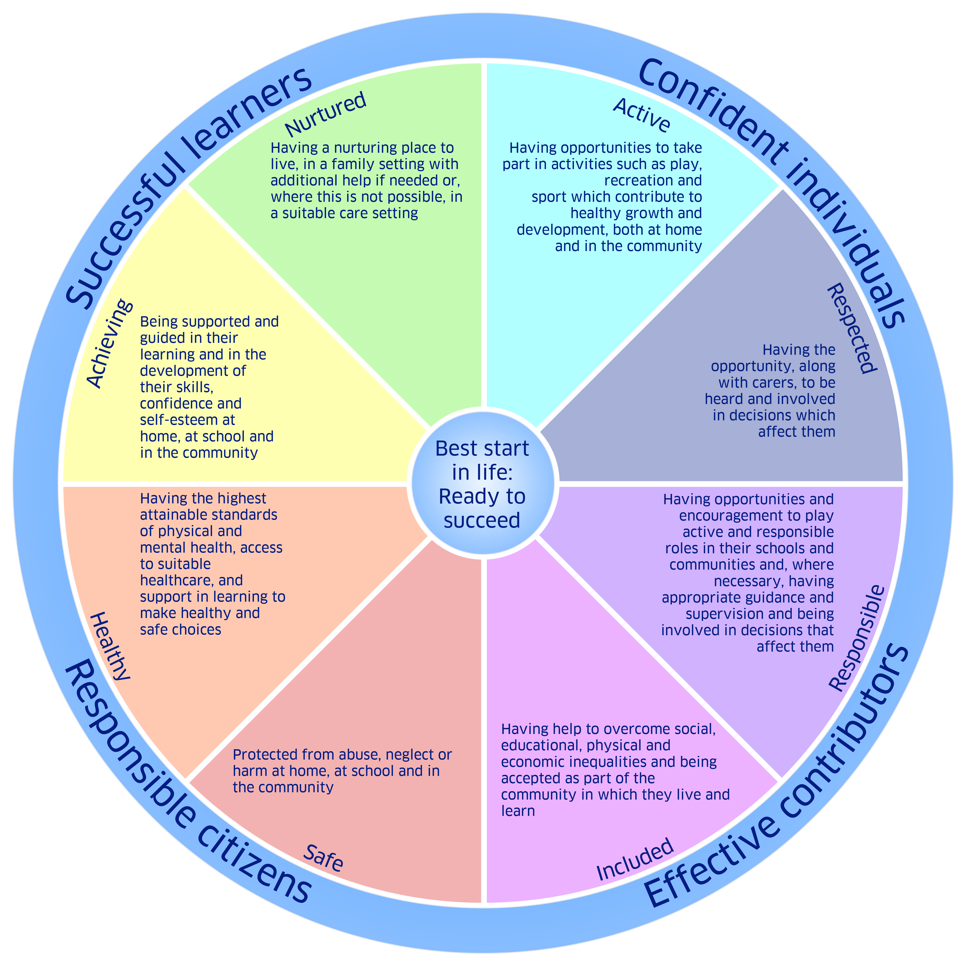
Wellbeing is broader than child protection and how we tend to think about welfare. To help make sure everyone – children, young people, parents, and the services that support them – has a common understanding of what wellbeing means, we describe it in terms of eight indicators. The eight wellbeing indicators are commonly referred to by their initial letters - SHANARRI.

References and Other Reading

Rothienorman School Restorative Approaches Leaflet

Better Behaviour, Better Learning, the Discipline Task Group, 2001
http://www.scotland.gov.uk/Publications/2001/06/9337/File-1

Better relationships, better learning, better behaviour, 2013
http://www.scotland.gov.uk/Publications/2013/03/7388

Building the curriculum for excellence through positive relationships and behaviour, 2009
http://www.scotland.gov.uk/resource/doc/316280/0100664.pdf

Improving relationships and positive behaviour in Scotland's schools, 2008
http://scotland.gov.uk/Publications/2008/04/15100117/0

Preventing and Tackling Bullying, Advice for Head Teachers, Staff and Governing bodies, 2011
https://www.gov.uk/government/uploads/system/uploads/attachment_data/file/368340/preventing_and_tackling_bullying_october14.pdf

UN Convention on the Rights of the Child – In Child Friendly Language – UNICEF
http://www.unicef.org/rightsite/files/uncrcchilldfriendlylanguage.pdf

GIRFEC
http://www.scotland.gov.uk/Topics/People/Young-People/gettingitright

Included, engaged and involved part 2: a positive approach to managing school exclusions
http://www.scotland.gov.uk/Publications/2011/03/17095258/0

More Choices, More Chances
http://www.scotland.gov.uk/publications/2006/06/13100205/0

Pupil Inclusion Network Scotland
http://www.pinscotland.org/

