Open Afternoon Feedback
Thank you very much to everyone who made it along to our Open Afternoon on Friday 6th May 2016, it was brilliant to get such a great turn out and the pupils really enjoyed showing you their learning.
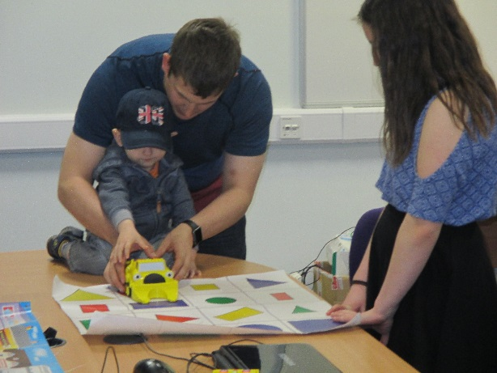
We got some great feedback with absolutely everyone saying they enjoyed it, found it useful to hear about restorative approaches and interesting to hear about so many of the things we have been doing in school this year.
A few people said they were keen to try a few ideas at home and asked for weblinks:

Hit the Button (maths game): http://www.topmarks.co.uk/maths-games/hit-the-button
https://itunes.apple.com/gb/app/hit-the-button-maths/id1001893116?mt=8
Sock Puppets: https://itunes.apple.com/us/app/sock-puppets/id394504903?mt=8

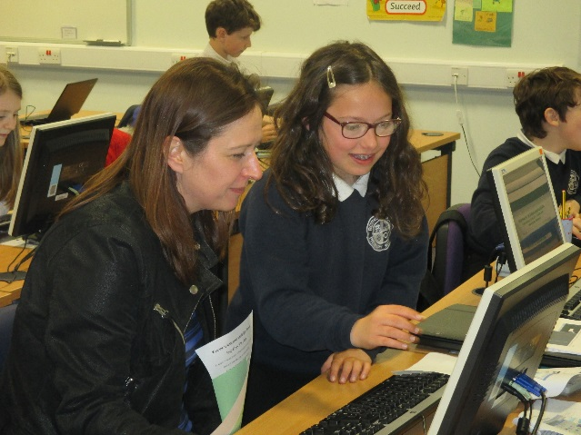
Lots of people said they would have liked a longer time in the classes, which I can completely understand as there was so much to see. This is something we will think about if we do it again but we have to be careful not to lose the focus of the children so it’s a difficult balance.
You seemed to feel that it was a good format with a mix of presentation and more active but nice and informal going around the classes.
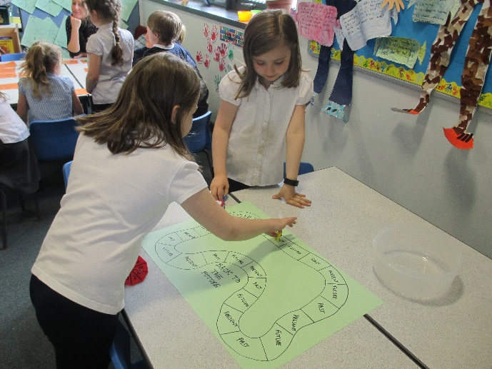
It was commented that Friday afternoon was generally a good time for it to be held. It was mentioned that it would be good to get information about the format and duration of the afternoon in advance. We will bear this in mind if we do it again; it will be easier to provide this information in advance now that we know the likely attendance.

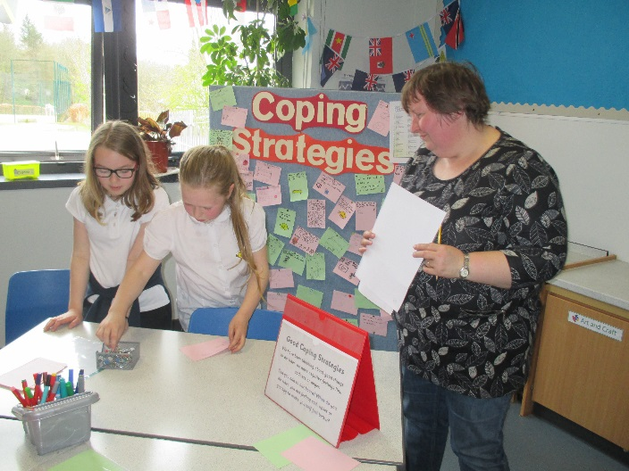
There were requests for information on restorative approaches and behaviour management to be covered at P1 induction each year. This is something we can certainly do if there is interest for it. Parents were very positive about our approaches to behaviour management and were reassured to hear about them in a little more detail. It was lovely to hear that the children are able to explain about these approaches and that some of you are noticing a difference in their behaviour and how they deal with things at home too.

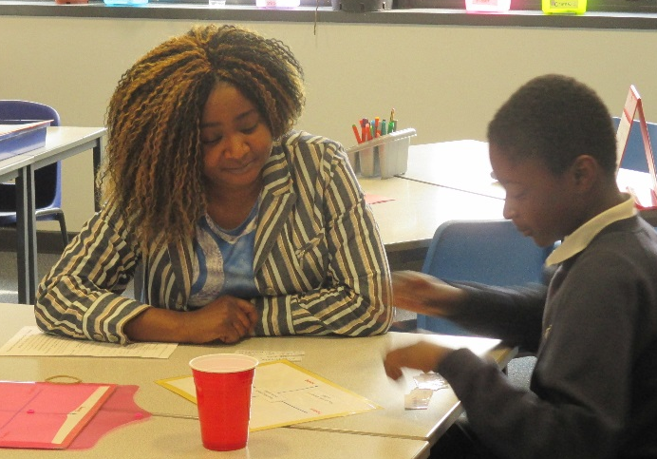
Science was mentioned as an area that you’d like to hear more about as well as how group interactions and social dynamics are discussed. We had been thinking about a friendship bench / stop but the focus has mainly been on the new playground equipment so we’ll discuss this again with the Pupil Council and decide how to progress this. There was a request for information on certain new techniques or approaches such as number pairing. Otherwise there didn’t seem to be anything else that you wanted to know more about. In fact it was commented that the information that’s been sent home to parents recently has been great.
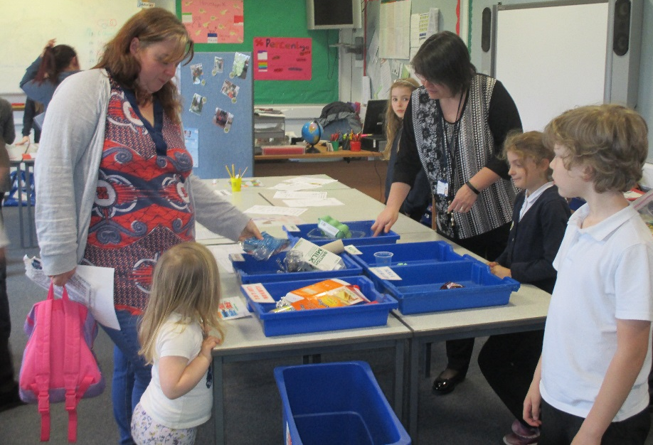
Lots of appreciative comments about the information that the Citizenship groups (Pupil Council, School Grounds, Library, Litter and Waste and ICT) presented. You liked hearing about the different learning techniques and the children demonstrating what they do in things like Viking projects, Growth Mindset, sign language, literacy, numeracy and music.
Many of you commented on how proud the children were of their achievements and how confidently and well they spoke of their learning.

You seemed to really like the informal, relaxed and comfortable atmosphere where you could move around at your own pace.

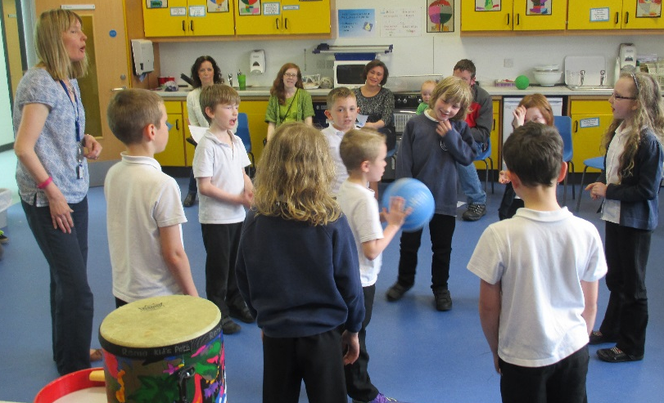
All of this feedback is really useful to us and we will bear it in mind for the future. The Positive Behaviour Policy, Restorative Approaches presentation and leaflet will be added to our website as will some weblinks. I will also put the School Improvement Plan Consultation document (evaluating last year’s and draft plans for next session) on the website for anyone who has not had a chance to complete it yet. Once I have received everyone’s feedback, I will summarise the responses and we will use this information to help us to finalise plans for next session.

